BELGIAN UFOLOGY: WHAT FUTURE DEVELOPMENTS ARE TO BE EXPECTED
AFTER THE PETIT-RECHAIN FIASCO?
SOBEPS IR: Sobeps Investigation Report.VOB1:
First SOBEPS report on the 1989 Belgian ufo wave.VOB2: Second SOBEPS report on the 1989 Belgian ufo wave.
I. Introduction
On July 26, 2011, the news that the famous Petit Rechain picture was a fake made the headlines around the Ufo world and elsewhere. Between 26/07 to 03/08, from India to China, through South America and the United States, the GEIPAN French Survey Program inventoried 86 communications on this topic.
Immediately warned by a call on his cellphone, Mr. P. Ferryn, Chairman of COBEPS, then on vacation in France, asked Prof. Meessen to get in contact with the self designed author of the falsification and issued the following statement the next day:
II. "The facked
Petit-Rechain picture does not put in question the extraenity hypothesis of the
Belgian Ufo wave."
From "La
Dernière Heure" of July 27, 2011:
"President of the Belgian Committee for the Study of Space Phenomena (COBEPS) Patrick Ferryn, considers that the
false Ufo picture of Petit-Rechain (Verviers) (...) doesn't suffice to downgrade the whole ufo wave over Belgium of unidentified flying objects sightings that started in November 1989 and lasted several months. This photo was the result of a hoax, his author has now admitted. The President of COBEPS stresses that his confession put an end to a case which had been scrutinized by several specialists including a professor of the Belgian Royal Military Academy. M. Ferryn had himself attempted to demonstrate (...) that this document was a forgery, not an easy task as the picture, taken on a dark background with no front or background, did not allowed any dimension or distance estimation, making thus very difficult to reach any conclusion about its genuineness.
On 29 November 1989, fourteen gendarmes of the Eupen region had observed a strange aerial phenomenon in the sky (...) and 150 additional testimonies were gathered to corroborate their claims. During the following months, other phenomena of the same type were observed in the Liège region, in Brabant, Brussels, in the suburbs of La Louviere. All in all, the whole Southern Country of Belgium seemed to be mainly affected by this unexpected UFO wave."
III. Yearly COB
statistics
Since nearly 40 years, I have been collecting and regularly updating the COB with all UFO notifications (see definition below) which I have been able to collect. Most of them come from the SOBEPS archives, for which I was an active member as a field investigator since July 1972. Without pretending to be complete, this database represents IMO the most detailed and complete complitation I know for Belgian ufo cases.
Table I gives cases figures for the1989-1993 period:
Table I: COB 1989-1993

Périod | Number  of |  | Invest. | % | Pan-D | % | Doc
 | notific | witn
1989-1 | 11 | 13 | 6 | 54,5 | 5 | 83,3 | 0
1989-2 | 216 | 321 | 170 | 78,7 | 102 | 60,0 | 4
1989-3 | 227 | 467 | 162 | 71,4 | 75 | 46,3 | 20
1990-1 | 320 | 583 | 190 | 59,4 | 76 | 40,0 | 27
1990-2 | 127 | 412 | 72 | 56,7 | 37 | 51,4 | 6
1991-1 | 150 | 279 | 109 | 72,7 | 65 | 59,6 | 6
1991-2 | 74 | 153 | 64 | 86,5 | 33 | 51,6 | 2
1992 | 94 | 193 | 79 | 83,2 | 40 | 50,6 | 11
1993 | 63 | 110 | 45 | 71,4 | 23 | 54,5 | 2
Total | 1,282 | 2,531 | 897 | 70,0 | 456 | 50,8 | 78

Periods
1989-1: 01.01 -> 30.09.1989
1989-2: 01.10 -> 30.11.1989
1989-3: 01.12 ->31.12.1989 Yearly total: 454
1990-1: 01.01 -> 30.06.1990
1990-2: 01.07 -> 31.12.1990 Yearly total: 447
1991-1: 01.01 -> 30.06.1991
1991-2: 01.07 -> 31.12.1991 Yearly total: 224
1992 : 01.01 -> 31.12.1992 Yearly total: 94
1993 : 01.01 -> 31.12.1993 Yearly total: 63
Grand Total: 1,282
COB: means "Catalogue des Observations Belges". While being sometimes referred as "Franck Boitte's catalog", I for many reasons disagree to this appellation, the most important being that it's the result of a collective and cumulative effort from the part of the many SOBEPS most of the time obscure investigators who over the years contributed to the elaboration of this always open to revision catalog.
COB characteristics
The COB starts at the early years of the Ufo lore (1947 and before) and extends to the recent years.
Every entry is divided into 5 parts:
1/ Identification line
Entry sequential number in the file/location/province/date/local time/"E" if there exist an IR/type of object described (TR, RE, SV, etc.).
2/ Number and identification of witness(es)
For reasons of privacy, only their initials - when known - are indicated. Under special circumstances, and only if it helps to discriminate between cases, the full names are punctually communicated to researchers whose past realizations and seriousness are recognized and provided they asked for them.
3/ Weather and sky conditions (when known)
4/ Narrative
With more or less details, depending oncases
5/ Additional information
Source/credibility/strangeness ratio (on
5)/GEIPAN appreciation (Pan-A,-B,-C,-D)/index number of the 1:10.000 IGN staff map.
COB basic rules
To be included in the COB, a minimum number of prerequisites are to be met:
1. The case must fall within the Belgian borders.
Exceptions exist when the case occurred at sea or very close (10 miles or less) of the borders.
2. Location, date and time must be reasonably known.
A few examples of cases that will not find their entry in the COB are:
2.1. when only the year is known,
2.2. when location is absent, erroneously spelled or even doesn't exist.
3. As in classical literature, each input refers to a certain unity of time, action and location.
I limited the first parameter to ten minutes and the second to a radius not exceeding 1 mile.In other words, multiple observations relating to the same (or group of) witness(es) separated in time by more than 10 minutes and/or witnesses moving over a mile give rise to distinct COB entries.
4. Some cases which do not specifically refer to the UFO lore (so-called "religious" apparitions, "ghost" hauntings, orbs, crop circles, etc) are included when well documented and possibly related to ufo events occuring in the same period of time and vicity and interesting enough.
Here is an input example for a very basic COB entry:
90-1/#21Waterloo - Brabant- 12.01.1990 - 07h20 - E
2: Mrs C.B., teacher and Miss V.T., school student.Moon azimuth 290°, elevation 6°.As the witnesses were in the av. d'Argenteuil, they remarked two black well delimitedstraight lines across the moon surface.
SOBEPS IR.
CR = 2, ET = 0; LN
Pan-B: chemtrail or clouds.393
Number of notific(ations):
I consider to be a notification any communication related to the Ufo subject, whatever its origin, support, nature, credibility, qualification and whether it was investigated or not, etc.
Number of witn(esses):
In the majority of cases, at least those which
were investigated that number is precisely known. In others (newpapers, …) it
may be vague ("many", "family X.", "a group of students",
etc).
Invest(igated): Number of cases for which there exist an Investigation Report
(IR, RDE in french).
Pan-D: Cases for which no
plausible explanation could be found after they had been investigated. This denomination refers to the GEIPAN classification:
Pan-A: definitely identified (stars, planes, forgeries, etc.)
Pan-B: probably identified.
Pan-C: insufficient information (the IR was incomplete; biased or badly lead)
Pan-D: no explanation to date.
Doc(uments): Number of cases for which there exist a photographic or camcorder "evidence" (there were no cell phones at the time).
Which doesn't imply all of them are Pan-D.
I can naturally not certify that some occurrences have not escaped my or my partners' attention.
Still being a W/P, the COB database is regularly expandind corrected as time goes by.
Inversely, some overlappings have been discovered here and there, due to the presence of duplicates.
But I think safe to say that the figure of 1,282 for the 89-93 period is accurate, minus or plus one hundred cases.﻿
Next﻿﻿

V. Global analysis
I don't see any reason to consider that the statistical time daily or wave yearly UFO occurences distributions should comply either to a 24 hours or a 12 months periodicitybased on the Roman calendar. I have anyway kept a 12 months distribution for convenience, even if my own intuitive opinion events sequencing leads me to consider a 28 day lunar calendar to be more appropriate.
This has several consequences. As it had been the case for the1987-1988 period, 1989 started with very few incidents with a mere 11 entries for the 01-09 period. SOBEPS had virtually fallen in a state of hibernation at this time. The last IR I had personnally completed dated back to Oct. 18,1981.
After Sept. 30, for a reason that still remains unknown, those figures dramatically increased during the next three following months. COB contains 12 notifications in October, 205 in November, 227 in December, making a total of 444 notifications for the last quarter of 1989 to be compared to 320 for the first half-year of 1991.
Despite a legend that the media helped to anchor in the public opinion, the wave did not began on November 29, but a month sooner, at a time when SOBEPS had fallen into a kind of limbo for many months if not years, making it inefficient to ring the alarm bell as the number of observations totally unnoticed increased. As an example, on a gathering I had in Brussels with some non ufo buff friends on October 15, one of them called my attention to a recent observation made by his father, a former until then skeptical airline pilot and POW[1]
I knew well, whose description made its UFO nature indisputable.Then, suddenly, and unexpectedly, in a single day, November 29 totalized ~150 notifications (~34% of 444).
See Tables II & III for details.
Table II: First 92 days of the wave
N° | Day | Nr | Inv | Pan-D | TMA
1 | 01/10
2 | 02/10
3 | 03/10
4 | 04/10 | 1 | 1 | 1
5 | 05/10
6 | 06/10 | 1 | 1
7 | 07/10
8 | 08/10
9 | 09/10
10 | 10/10 |  |  |  | 2
11 | 11/10
12 | 12/10 | 2 | 2 | 2
13 | 13/10
14 | 14/10
15 | 15/10 | 1 | 1 | 1 | 4
16 | 16/10
17 | 17/10
18 | 18/10
19 | 19/10
20 | 20/10 | 2? | 2 | 2 | 5?
21 | 21/10
22 | 22/10
23 | 23/10
24 | 24/10 | 1 | 1 | 1
25 | 25/10 | 1 |  |  | 4?
26 | 26/10
27 | 27/10 | 1 | 1
28 | 28/10
29 | 29/10
30 | 30/10 |  |  |  | 3
31 | 31/10
32 | 01/11 | 1 | 1
33 | 02/11
34 | 03/11 | 1 | 1
35 | 04/11 | 1 | 1 |  | 4
36 | 05/11 | 1 | 1 | 1
37 | 06/11
38 | 07/11 | 2 | 2 | 2
39 | 08/11 | 2? | 1 | 1
40 | 09/11 | 1 | 1 |  | 9?
41 | 10/11 | 1 | 1
42 | 11/11
43 | 12/11
44 | 13/11
45 | 14/11 | 1 |  |  | 8?
46 | 15/11
47 | 16/11
48 | 17/11
49 | 18/11 | 1 | 1
50 | 19/11 | 2 | 2 | 2 | 5
51 | 20/11 | 1 | 1 | 1
52 | 21/11 | 1 | 1
53 | 22/11 | 8? | 6 | 6
54 | 23/11 | 2? | 2
55 | 24/11 | 3 | 3 | 1 | 18?
56 | 25/11 | 1 | 1 | 1
57 | 26/11 | 4 | 2
58 | 27/11 | 1 | 1 | 1
59 | 28/11 | 9? | 7 | 3
60 | 29/11 | 149? | 102 | 73 | 179?
61 | 30/11 | 8 | 5 | 1
62 | 01/12 | 18 | 11 | 9
63 | 02/12 | 13 | 13 | 1
64 | 03/12 | 10 | 9 | 5
65 | 04/12 | 13 | 11 | 4 | 226?
66 | 05/12 | 8? | 3 | 0
67 | 06/12 | 6 | 3 | 0
68 | 07/12 | 5 | 3 | 1
69 | 08/12 | 3 | 2 | 1
70 | 09/12 | 4 | 2 | 0 | 88?
71 | 10/12 | 3 | 2 | 0
72 | 11/12 | 43 | 34 | 21
73 | 12/12 | 7 | 5 | 4
74 | 13/12 | 5 | 5 | 3
75 | 14/12 | 3 | 3 | 1 | 87?
76 | 15/12 | 10? | 6 | -
77 | 16/12 | - | - | -
78 | 17/12 | 9 | 6 | 3
79 | 18/12 | 4 | 3 | 4
80 | 19/12 | 5 | 4 | - | 89?
81 | 20/12 | 4 | 4 | -
82 | 21/12 | 3 | 3 | 3
83 | 22/12 | 12 | 6 | 3
84 | 23/12 | 1 | 1 | -
85 | 24/12 | 19 | 12 | 5 | 67?
86 | 25/12 | 3 | 2
87 | 26/12 | 4 | 3 | 1
88 | 27/12 | 3 | 2 | 1
89 | 28/12 | 2 | 2
90 | 29/12 | 1 |  | - | 52
91 | 30/12 | 2 | 1 | -
92 | 31/12 | - | - | -
N° | Day | Nr | Inv | Pan-D | TMA
Total |  | 431 | 314 | 169
TMA stands for
"Total Mobile Annuel", "Total Moving Average".There is a "?" in the third column when the figure includes notifications whose date is not exactly known but had to be assumed ("beginning of December", …). This also explains the minor discrepancies between figures in Table II and I.
Table III
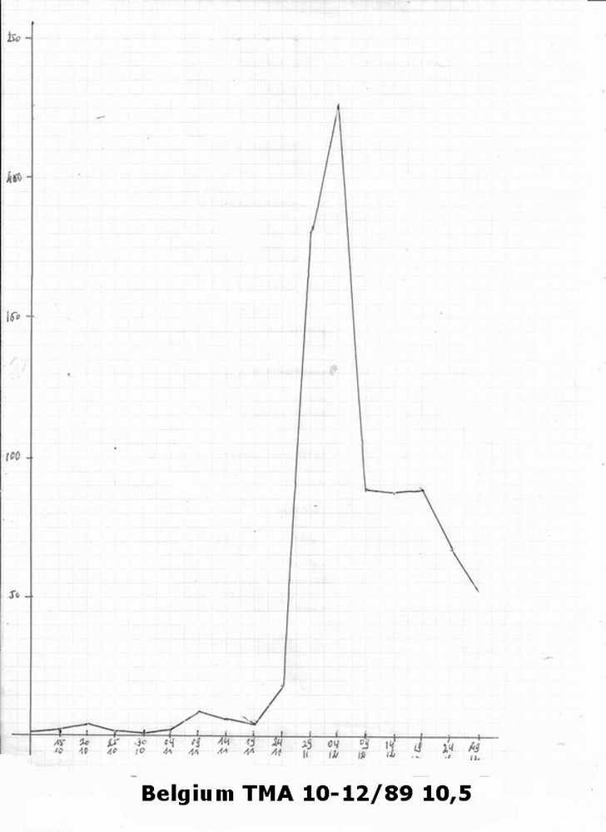
In this sample, the TMA was computed on a fixed 10 days basis moving on by 5 days.Last column in Table II shows that the wave started smoothly around Oct. 10 and reached its peak during the 29/11-09/12 period after which it started to slowly dwindle.As media contimation had not had the time then to induce mass reporting hysteria (bruit de fond), the signal/noise ratio was then still high.Table I shows that after 1990, despite the hype and armchair confabulations of social psychologists, the number of notifications was no more on the increase but rather regularly deflating.In my opinion, this suffices to show that something weird was actually occuring on in the southern part of Belgian sky, and more precisely along its Germany border during the last quarter of 1989. But what ? The datas also clearly show that the (nothern) Flemish part Belgium along the same border was spared by that rash of sightings. Again : why?
A possible reason, yet not completely satisfying for this lack of Flemish reports, could have been the lack of active investigators in the North half of the country. As we have seen, SOBEPS was dormant at the time while very disappointed with the lack of results of his 40 years extanded studies and utterly demotivated, Bonabot had put his GESAG association in complete hibernation since 1985 before practically disbandying it three years later. Before 1991, nobody had replaced his team in the South half of Belgium. Opposite to the debunkers' dire predictions, the number of notifications decreased inexorably during the second half-year of 1991. In apparent paradox, at the same time, the number of IR increased. Yet, all things considered, this is finally normal: with virtually the same staff of increasingly experienced and motivated field investigators, the number of notifications deemed worthy of reporting was at the same time diminishing in both volume and quality.
The evolution in percentages of Pan-D cases confirms this tendency to the reflux of the tide: with the exception of the 01->06.1991 file (59,6%), they all stand below or around the overall 51,5% average, while the 10->12.1989 files (89-2, 89-3) stand far above. This strengthens the idea that independently of the number and enthusiasm of the investigators, an objective real phenomenon unfolded during the last quarter of 1989, when something weird actually took place, the subsequent data being more or less contaminated by a process of media contagion and growing mass hysteria.About 883 cases, more than two out of three notifications, were investigated and gave birth to an IR. Considering that those results were achieved by a small group of enthusiastic volunteers with limited resources in qualified personal, fundings and analytic facilities, I personally find this to be a remarkable achievment and would again like to cheer up the efforts of these 124 investigators or so whose names have never been mentioned anywhere.I have build a list of their names.
Everybody knows how easily statistics can be made to say what you want them to and how their presentation can be misleading. The above figures do not take into account the pre-selection made by "rule of thumb" and thus without any scientific justification of the notifications that reached SOBEPS headquarters. While about one third came by post or from gendarmerie reports, most (at least in principle) were automatically recorded on 90 minutes audiotapes, nearly
500 of which have been stored.
They of course contained many repetitive calls from the same witness(es) who eagerly requested someone would come to assist them and please take their account intoconsideration.
Among those calls, were only considered as "attention worthy" those that met certain unspoken criteria. For example, notices where the caller simply forgot to clearly mention where to call him back, others which seemed too obviously trivial or in the contrary coming from an apparently emotionally distraught person ("contactee"), were almost immediately snickered down and thrown to the waste basket without even getting the status of a signaling form, let alone, or very exceptionally and only by mere luck, investigated. As in so many sociological polls claiming to be scientifically carried on, we catch here, hand in the bag, a sneaky way to systematically biase a sample to its roots by screening it so as not to take into account the in a way or another notifications that are "too way out". Conversely, the contactor (most of the time, a group of witnesses) who was "every day hanging on the phone" asking, as I have seen many examples and could give names, that they be ASAP dispatched a preferably experienced investigator on site, were more likely to be listened to than the shy one who will only call once, even if his narrative often outweighed in interest the precedent notifications that most of the time had mundane explanations: stars, satellites, airplanes, etc.
Even then, the analysis of communications coming from too far out places or places where no active investigator was available were simply postponed before, as the ininterrupted flow of reports went on, they finally fell into oblivion.
Small communities of enthusiasts - some of which eventually will later on turn over to become investigators - who claimed repeated observations would prove very difficult if not impossible to ignore, and would gradually extend their
influence as the wave unfurled, monopolizing the front stage and making already overbooked unpaid investigators lose a considerable amount of time to listen to their generally uninteresting and unsubstantiated stories.
This is the dark side, never mentioned by the debunkers or armchair ufologists, of the investigation side of the ufo business and also a trick known by all pollsters who have been using and abusing of this situation for years to manipulate public opinion, mainly in economical, political or religious issues.
Next

[1]: Prisoner of War

VI. As other documents exist, the bogey Petit-Rechain picture is not enough to invalidate the entire
Belgian wave.
This is the kind of affirmation you see blooming on the net now. Skeptic psychologist Jean-Michel Abrassart links this way of reasoning to the "cognitive dissonance syndrome", a concept which was documented by Leon Festinger.
As I asked myself if there was any validity to the above (VI) declaration, I came to the conclusion we must concretely consider how this statement factually applies to the Belgian wave.
But let us first consider a few side aspects.
VII. Reports with "traces"
Under "trace", I mean cases including any material or indication that could imply that an unexplained phenomenon corresponding to the rather large UFO spectrum took place.
All in all, this corresponds to the (nowadays insufficient and certainly no longer appropriate, but at the same time best known) Prof. J.A. Hynek CE2 category.
Three situations are to be considered: ground traces, radar echoes and effects on the witness(es). The question is: "Out of the 1.282 COB entries, how many "traces" are present and what is their possible scientific value, if any?".My intention here is to demonstrate that, aside an historical point of view,the results are rather frustrating.
VIIa. Ground traces
I only found two cases of claimed landings having left possible ground traces. At closer look, both appear to be of very little value:
90-1 / #279. Stockay St-Georges - Liège - 04.05.1990 - ~ 23:15 - E
M. J.D., retired archaeologist and his wife.
He had been checking his greenhouse and was about to go home when he heard the barking of nearby dogs. Intrigued, he lifted his head to the sky but didn't notice anything of special interest. Turning back to the ground, he saw in a field, 100 m away from him, a pyramidal or conical illuminated shaped object toppled by what looked like "a bright white mushroom cone" floating about one feet above the ground.Mr. D. approached about 50 m before he was stopped by a wired fence. During the next few minutes, he remained there, contemplating the object whose color suddenly changed from white to orange while its upper part rose. Under it appeared on the object a small evased looking cavity over which the upper part fell back again. Surprised, but not really alarmed, the witness called his wife, who could also observe the landed structure. In her opinion, there were two small antennas on top. The couple then decided to rejoin their nearby home to ask their son G. to come to videotape the scene. But when they came back, there was nothing more to be seen. The next day, M. J.D. went to the meadow where he says he discovered four circular diggings about 1m in diameter in the ground and a thin layer of yellowish powder sprayed on the grass. Strangely behaving for a former archaeologist, he didn't cared to collect any sample or make phictures of them. When the investigator came to interview him a week later, it had been repeatedly raining and every possible material element had disappeared. Observation duration: 5 minutes.
Investigators: P.Vidal for EUROUFON and R.Tercafs for SOBEPS.
Eurufon News No. 1, September 1990; INF 83, 15-16, INF 85, 32; VOB1, 217
CR=3, SR = 4; CE2
Pan-D
418
Interestingly, G.D's son declared that on April 14, 1990, he had observed at the same place a "gigantic low flying cigar" (COB entry #198). He made artistic representations of what his parents reported, which he completed by hieroglyphs that he calls "cabalistic", "magical" or "aliens".
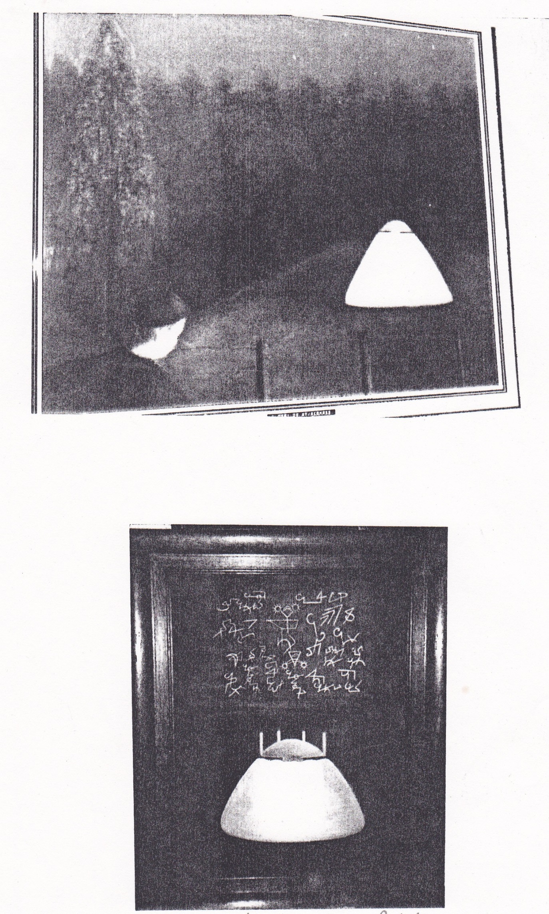
St. Georges - ill. G.D.
Though still considered "Pan-D", this case becomes impaired as soon as we question its context. Mrs. G. Van Overmeire,
at the time Head of SOBEPS Investigation Network, categorized those events in the realm of "ufological-mystical wishful
thinking" Now let us consider the only other case which might be labelled a "ground trace":
Next﻿

90-1/#114 Flémalle - Liège - 06.03.1990 -??h - E
A "mysterious trace" was discovered on the estate property of M. L.D.(in another version, of a teacher, Mrs. J.).It consists in "a large 3-4m in diameter rather oval mark where the grass changed to yellow."In an alternate version, the "trace" was made of two circles separate, the first approx. 4m, the second 8m in diameter where the grass was more
"dense and dark" than it should "normally" have been.This "observation" (no ufo was actually seen) was simultaneously
reported to SOBEPS by the Amay gendarmerie and by M. S.B., a then SOBEPS ® enthusiasitc investigator, who filmed the scenery.The investigation group gathered up two representatives of the local police, long time SOBEPS consultant Mr. Jean-Pierre Auquière, laboratory assistant at the Catholic University of Louvain, Mr. Michel Voue, physicist and Prof.Gillet, from the laboratory of Plant Biology, both appointed to the University of Namur plus some local journalists. On April 23, Prof. Gillet issued a verbatim record:
1 / [I noted] the presence of a few small strains on the ground that follow the main footprint trail in the direction of the prevailing winds the week before the trace was discovered.
2 / A thin trail rather straight to the main trace, in the same direction.
3 / Dry grass from the upper end of the sheet with a chlorophyll deficit.
4 / No notable radioactivity on the Geiger counter.
Prof. Gillet concludes "[there is] nothing in all this [that] confirms the existence of a Ufo landing trace" and refers to probable fungal mycelium or the localized contamination by a chemical defoliant.
Notes: 1/ An article on UFOs had appeared the previous day in the newspaper "La Lanterne".
2/ Data are imprecise.
3/ Seen the existence of Prof. Gillet's report, I have exceptionally marked "E" for "investigated" in the header of this case, although there is no IR to be found in the SOBEPS archives.
4/ The survey was conducted at very short delay, which is a positive point.
5/ The negative conclusions of Prof. Gillet had the paradoxical consequence that SOBEPS was accused by some ufologists (such as M. S.B.) to be "government appointed in trying to hide the truth away from public knowledge."
6/ No Ufo was claimed to have been observed.
CR=4, SR=1;TR
Pan-A: mycelium coupled with defoliant soil contamination.
425
VIIb. Radar screen echoes
The first radar blip or rather series of radar blips which comes immediately to mind was registered on the 30-31 March 1990 night during an incident that lasted about two hours.
Two FAB F-16 planes were scrambled in pursuit of a (at start, a group of) supposed UFO(s) that were said to be simultaneously visually visible from the ground and on radar screens. But it was from different groups of people as they desperately remained during all the chase visually invisible to the F-16 pilots.
I will not again return to the heated discussions that incident have aroused. I want only to remind that the main - and might I say, only remaining - proponent of the view that those echoes resulted from the presence of one or more unknown aircraft(s) is Prof. Meessen who has heavily engaged his reputation as a scientist and devoted considerable time and an equally large number of pages on his website and elsewhere to promote his conviction that the radar echoes were due to the presence of a "alien airbone craft" until he, under the repeated attacks of his skeptical opponents, had finally to quite pitifully admit that the whole affair resulted "in all likehood to a clutter of rare aatmospheric phenomena aggravated by a poor calibration of the FLIR embarked F-16 radar system (then in maintenance full replacement), coupled by a confusion from the ground witnesses with twinkling planets and stars."
Which was exactly what, based solely on the azimuths and elevations signaled by ground witnesses, many SOBEPS confirmed investigators and other groups such as the Flemish NUFOC had concluded long before Pr. Meessen, without having engaged themselves in much complicated calculations or scholastic elaboration. Here is a short resume of the facts:
90-1 /#155 Ramillies - Namur - +30.03.1990- 22:40 - E
1: Mrs. R.
Cloudless skies, ground temperature near 0°, it freezes.
No visible moon.
Mrs. R, housewife constable, was having a chat at her home in the company of some female friends, when she drew their attention to "funny moving lights in the sky". She called her husband who in turn, relayed the information to his colleagues, and at 23:00, to Glons NATO radar station. Twenty gendarmes on duty to carry out road alcohol checkings patrolling on a territory of about 400 square miles were diverted from their mission to look at the starry sky. They quickly remarked the presence of multicolored pindrop lights "substantially brighter than stars or planets" which were seemingly moving erratically and regularly changing color. According to their statements, including the one of Captain P., of the Wavre Brigade, eight different "triangular" changing shapes were spotted.
Observation duration: 2h20"
Notes: 1/ There was a temperature inversion over the southern part of Belgium that night.
2 / See Wavre, and Ramillies 900417, 900430.
VOB1, 225, 339
CR=4, SR=2; NL
Pan-B: probable stars and local temperature inversion
408
90-1 / #156 Ramillies - Namur - 31.03.1990- 01:00
The FAB scrambled two F-16 in order to intercept the supposed UFOs. Ground observers reported that upon their arrival, seven objects immediately faded out into nothingness. The latter started performing evasive maneuvers that involved sudden horizontal and vertical accelerations with the emission of rapid outbursts of light changing from white to red. Although no pilot was ever able to visually see any object, both obtained very sharp radar echoes of electronic lock-on whose images were published in Paris Match February 13, 1997 under the signature of French free lance journalist, M-Th. de Brosses.
VOB1, 339
CR=4, SR=2; NL
Pan-C
408
90-1 / #161 Ramillies - Namur -31.03.1990 - 01:05
Report of Flight Captain Yves Meelbergs', one of the two F-16 pilot:
"Night scramble, that is to say two fighter jets were sent at less than ten minutes delay to intercept and, if possible, identify an (sic - initially eight were said to have been observed by the gendarmes to begin with) unknown flying object observed by several witnesses on the ground and also detected by several stations and air traffic control radars of the F-16 jet planes. Soon after the take off we (...) spotted [the UFO] very clear on the radar screen specifying its altitude, speed and direction. When we received [echo], it was at 5,000 feet (~1 600 m) and moving at a speed [not exceeding] 50 miles (90 km/h). In aviation terms this amounts to almost hovering (...). During the lock-on radar, target was 48 km (sic) distant. When we set sail on it, it did not initially react. But when I found myself halfway, I saw its speed accelerating to fantastic proportions. The same reaction was verified by the second pilot. Sudden acceleration to Mach 8, 9 or 10 (9,000, 10,000 or 11,000 km / h). Incredible. As the radar is limited to Mach 2 (1,800 km / h)[1], the pilot can only give a relative estimation of the speed increase he sees. It's like the thing had intended: "OK guys, you have had enough now."
And these changes of altitude: from 10,000 feet to suddenly 60,000 to 70,000 feet in a split second. A pilot in a technologically advanced aircraft simply would not survive such altitude variations. At that time, we got more radar
contact and locks-on but we could find little more information on the tape. I heard later on that the NATO bases in
Belgium, Germany and England had been put on red alert that night. (emphasis mine, FBE).
Reporter: "What was in your opinion the nature of this UFO?"
Pilot : We never found a clear and satisfactory answer. But we can say what it was not: a temperature inversion or a U.S. stealth aircraft. Given the multitude of testimonies from different [ground] sources, the only objective fact is that there was indeed a [material] object in the sky that night (...) Yet, there will always be skeptics! But according to experts, the inversion [hypothesis] must be ruled out. And then just go to the many eyewitnesses to understand that the phenomenon was neither of atmospheric origin nor to be attibruted to simple mind characters... The size of this object (on the radar screen) was really impressive."
Reporter: Twenty years after the incident, what is your opinion on this rash of UFO observations?
Pilot: I remain open to any possibility and I still meet people who are trying to find a rational explanation. Lest's say the subject is somewhat taboo for some people... But I know that most witnesses are reliable people whose story is fairly consistent, a fact quite rare in this kind of observation".
VOB1, 173-188, 225-235; Humo Magazine, Jan Hertogs, 24.9.1996.
http://www.mondenouveau.fr/index.php?option=com_content&task=view&id=251&Itemid=79
CR=4, SR=3; LN
Pan-C
408
Apart from this to say the least unconvinging serie, I discovered five additionnal less mediatised reports:
Next

[1]: Mach conversion into km/h actually depends on various parameters such as the altitude and the hygrometric densityof the surrounding atmosphere.

89-2 / # 131. Eupen - Liège - 29.11.1989 - 18:30 -E
Gendarmerie MDL Chief A.C.
Clear and cloudless sky. Sunset at 16:42, moonset at 14:46, HL.
On advice of his colleagues Von Montigny and Nicholl, he called Bierset airport.
He was told they had no information there, but that an AWACS had been sent for identification purposes
."Subsequently, Bierset called me back to say that they didn't know (sic) [how] to detect any [unidentified] target on their radar and that it had to be moving beneath 1,000 m." (...).
Observation duration: 10 minutes
Enq. Patrick Vidal
CR=4, SR=2; ND
Pan-D
436
90-1 / #137 Zaventem (Brussels) -Brabant - 18.03.1990 - 20:30
Airport ground radar spotted 44 very sharp zigzaging echoes over an area ranging from Brussels to Liege, in the direction of Luxembourg. Since they did not have the transponder signal, they could have been caused by the trajectory of a UFO.
Those tracks joined the one of a civilian airplane and interwoven with it.
Source: Prof. Meessen's diaries. No IR.
VOB2, 407
314
90-1 / #192 Namur - Namur - 12.04.1990- ~21:29
2: Gendarmerie first sergeant L.L. and a motorist.
Followed by a car, he was driving in the direction of Charleroi when he noticed through the car windshield two large bright white lights coming in his direction. He stopped his car and realized what he had first taken for street lighting belonged to a dark triangular object whose size, with outstretched arm, reached 5 cm. It was moving in the direction of Suarlée.
The other driver who had stopped too said:
"Happily you are there, otherwise I would have thought I had been dreaming."
The witness added: "I have seen many AWACS flying over the country and that object was just not that one or any other plane.
"Observation duration: 2 minutes.
Note: The Chief MDL Marc P. at Floreffe gendarmerie who ensured that evening the survey clearance of Namur states he received many calls from colleagues and civilian witnesses at the same time and warned SOBEPS and Glons, without no known result.
VOB1, 190
473
91-2 / #8 Zaventem - Brabant -26.08.1991 - 21:30 - E
2: M. V., air traffic controller in Zaventem and Mr. X.
According to a 21:30 phone call to the ACC, M. V. and another man saw "a luminous mass with red, white and green streaks moving slowly in the direction of Halle (SW).
"At 21:39, two small diverging echoes appeared on the ACC radarscope.
At 21:52 an swapping from Bertem to that of St Hubert antenna made the blip to disappear deom the screens. Turning back again to the Bertem antenna made the echo become visible again while CRC Glons as well of the BELGA Center had no radar contact. Which led to suppose once more that the target was flying at an altitude of less than 1,000 m.At 220:13 p.m., final disappearance of the echo on all radar screens.
Observation duration: 23 minutes.
The file was transmitted by the Zaventem ACC on basis of M. S.M's report.
Investigated by Fritz Devos and Patrick Vantuyne for Pro Ceeti.
Pan-D
315
92 / #4 Moresnet - Liege - 21.01.1992- 17:50 - E
1: M. G.P.'s wife.From her home, she observed "an immobile strong light mass" at 10-15 elevation. As it started moving, she filmed the object during thirty seconds with a Sony camcorder video 8CCD Handicam System. It had the appearance of two yellowish-white joint round headlights and was drifting at a distance of approximately 700 m and an height of 150 m above the ground. As it continued to grow in size, it changed into three points of light with a smaller center, aimed towards the direction of Montzen before it disappeared behind a hill.Upon immediately calling the 101, Mrs. P. was put in communication with the first MDL H. who checked with the CRC Glons radar. He was told they had had nothing out of the ordinary on their screens.MDL H. relayed back the info to SOBEPS and sent a detailed report.The film only shows a bright moving object without any details.
Observation duration: 2 minutes
INF84, 4, VOB2, 42-43
CR=2, SR=1; ND
Pan-C
431
This provides a total of six cases, none of which is really convincing and comply to Hynek RV definition (in the last there was no radar echo at all). Asked about those reports, the former Director of SEPRA J-J. Velasco diplomatically answered
to a question from a viewer in the 20:00 p.m. News of TF1 on November 8, 1990:
"SEPRA has no been mandated to investigate UFO cases that fall outside the limits of the French territory," while stating on another occasion: "The French surveillance system is provided by transhorizon radars that overreach the Belgian territory to the German border.I've not been informed that anything unusual was ever registered on its screens during the Belgian Ufo wave".
Another limitation is that the conditions for a good radar record and those for a good visual observation are conflicting. Visual reporting is the more detailed with a low flying object while conversely radar can not detect objects flying at low altitude. Additionnally, civilian radars do not detect targets that are not equipped with a transponder and it is furthermore highly difficult for private investigators to obtain records of military origin since they are not conserved for no more than a few weeks.Finally, such cases are only useful when they corrobate other (visual) ones for which there are reliable eyewitnesses. Those recordings can then be compared to check if a recorded radar blip was also visually observed at the same time by the same witnesses and when this is the case, give accurate estimates of its speed and trajectory.
In most cases, these data are not accessible to private investigators.In France, all radar data, be them local or issued from of neighboring countries, are collected and processed by the STRIDA (information processing system of air defense) network whose detection range extands to a radius of 450x450 km."
Sources:
http://scienceetovnis.eklablog.com/des-controleurs-radar-civils-ou-militaires-p61395
http://www.defense.gouv.fr/air/technologies/equipements/radars/radar
and:
http://benzemas.zeblog.com/394176-detection-radar-des-ovnis-les-cas-radar-optique-ro/# ixzz1YbMJujGb
As practically all observations occurred below radar coverage, one may wonder how ubiquitously those "ufos" knew about radar technical limitations?
Next

VIIc. Effects on the witnesses
Another surprising feature of this wave in regard of the high number of close encounters is the almost complete lack of effects on humans, animals and machinery:
• Cases where car motor engine went dead: none.
• Cases where witnesses suffered from skin irritation, burns, conjunctivitis, blood poisoning, vomiting: none.
• Cases where the witness says to have been paralysed: none.
• Cases where the witness says to have experienced anxiety, insomnia, depression: 3 occurrences, without direct correlation with the circumstancial evidence.
In one of them, MW was already in bad shape before his observation.
• Cases with electrical blackouts or domestic disturbances of TV reception:3.
Finally, I will mention two bordeline cases of "personality disorders", one of them I was sent to investigate:
90-1#66 Ferrières - Liège -06.02.1990 - 00:05 - E
1: Miss M-C.D., hairdresser, 22 years old at the time.
She phoned SOBEPS telling she wanted to speak to its president, M. Bougard,who happened to be there. She explained him what had occurred the evening before. On Bougard's request, she was sent a questionnaire that she returned back completed to SOBEPS. In it, she mentioned two additional witnesses, one of them a municipal local officer. When I went to her place, my efforts to meet Miss D. proved fruitless. Here is what seems to have happened from an interview I finally managed to get from her aunt:
M.-C. was lying on her bed in the house located behind the village church which she inherited from her adoptive parents. Around midnight, she heard a noise that sounded like a car motor in the street. She feared its origin could be caused by the unwanted visit of a former lover with who she had gone into sentimental trouble. At the same time, through the curtains, a bright white beam of light coming down from the front wall facing the church illuminated the room. There was a bright spot of blinking light like a car headlight coming from behind the nearby steeple of the church. At the same time, rectangular green fluorescent lights geometrically patterned appeared on the floor. When she walked over one of them, it immediately switched off to reappear at another place. Increasingly concerned, the young girl looked up and saw that the main light now seemed to be hardly at 20 m from away from her.
Losing all control, she hurriedly ran out of the house without even caring to cover herself and ran to seek refuge to her aunt living not far away.
After I had criss crossed her relative for several hours, Miss D. eventually phoned her and after many delaying hesitations, she accepted to have a brief phone conversation with me. The only information I could get from her was,
"You 'd rather ask M. Bougard as I already told him everything."
What concerns the other two witnesses announced, I managed to meet the municipal secretary who said he had not seen or heard anything of an Ufo nature while the other, only known by her first name, could not be located.
Enq. F. Boitte #73 of 04.08.90
INF84, 26
CR=1,SR=4
Pan-A: Ufo phobia
496
To my knowledge, the second case was never investigated and still less archived:
Charleroi(?) - Hainaut - end 12?.1989 - evening
3?: Family X.
As they were sitting for supper, their attention was drawn to a blinking light outside. The son, a youth of twenty years, rose to try to check what it was. As soon he opened the door, he instantly fell lifeless on the ground while the light disappeared. During the next half hour, he drifted in a delirious cataleptic state during which he pronounced garbled indistinct words. Called to the rescue, the family doctor could only prescribe sedatives to calm him down.
This case was transmitted for evaluation to the SOBEPS Investigation Network Manager. With the parents' agreement, he went in search of a hypnotist who would get into a more detailed account on what happened. After having found
noone willing to fulfill this role, he finally gave off.
VIII. Picture evidence
Let us now consider among the 1,282 notifications thoses where the presence of document(s) such as pictures, videotapes was signaled and try to assess their quality. I found 78 cases, a mere 6% out of the total which are summed up in Table IV:
Table IV: 78 picture cases in detail

 | N° | Date | Time | MW | S | Place | Prov. | P/C | 9(') | 10(’’) | Pan- | 13
89-1
(0 case)
 | p.m.
89-2
(3 cases)
1 | 8 | 20?/10 | betw.23-24hr | A.D. | m | Nodebais-Beauvechain | Bt | P | 1½ |  | D | 9
2 | 20 | 05/11 | betw.20h30-21h00 | … G. | m | Stembert | Lg | P | 2 |  | D | 9
3 | 26 | 10/11 | 20h05 | S.S.+ | m | La Louviere | Ha | 4P | 3 |  | B | 1
4 | 211 | 30/11 | 17h15 | E.D. | m | Gemmenich | Lg | C | 120 | ? | A | 2,5
89-3
(21 cases)
5 | 10 | 01/12 | 17h30 | M.T.+ | m | Horion-Hozémont | Lg | C | 60 |  | A | 2,8
6 | 19 | 01/12 | 19h45 | S.B. | f | Baelen | Lg | P | 5 |  | D | 5
7 | 27 | 02/12 | 07h45 | M.C.D. | f | Wahlain-St-Paul | Bt | 4P | ? |  | C | 9
8 | 51 | 04/12 | 17h15 | M.T.+ | m | Botrange | Lg | C | ? | ? | C | 3,8
9 | 52 | 04/12 | 18h45 | … R. | m | Eupen | Lg | +P | ? |  | D | 9
10 | 57 | 04/12 | 20h30 | E.K. | m | Eupen | Lg | +P | 90 |  | A | 2
11 | 87 | 10/12 | 19h00 | A.A | m | Thirimont | Lg | C | 10 | ? | C | 5
12 | 101 | 11/12 | 18h25 | L.P. | m | Trooz | Lg | +P | 5 |  | D | 5
13 | 113 | 11/12 | 18h50 | V.V.+ | m | Sombreffe | Lg | +P | 30 |  | D | 5,8
14 | 115 | 11/12 | evening | P.M. | m | Stavelot | Lg | C | ? | ? | - | 6,7
15 | 118 | 11/12 | 19h05 | V.V.+ | m | Suarlée | Lg | +P | ? |  | C | 5,8
16 | 125 | 11/12 | 19h40 | H.B.+ | m | Aubel | Lg | C | ? | ? | D | 5
17 | 130 | 11/12 | ~20h30 | H.B.+ | m | Banholt | Holl | C | ~5 | 270 | C | 3,5
18 | 145 | 14/12 | ~17h35 | A.V. | m | Welkenrath | Lg | +P | ? |  | D | 5
19 | 151 | 15/12 | 00h40 | V.B. | m | Gouy-lez-Piétons | Ha | +P | 40 |  | B | 2
20 | 188 | 22/12 | 18h30 | B.D.+ | m | Templeuve | Ha | +P | 45 |  | C | 6,8
21 | 198 | 24/12 | 17h45 | … G. | m | Sambreville | Na | C | ? | 600 | - | 6,7,9
22 | 200 | 24/12 | betw.18h30-18h45 | J.D. | f | Nimy | Ha | C | 2 | ? | - | 6,7,9
23 | 203 | 24/12 | 19h15 | G.G. | m | Lavacherie | Lu | +P | ? |  | D | 5
24 | 222 | 27/12 | ~09h00 | ? | m | Saive | Lg | C | ? | ? | A | 4
90-1(28cases)
25 | 11 | 03/01 | 21h00 | … H. | m | Liège | Lg | ~10 | 120 |  | A | 2
26 | 23 | 12/01 | 18h45 | J.F. | m | Woluwé-St.-Lamb. | Bt | +P | 30 |  | B | 2
27 | 25 | 13/01 | 22h00 | M.S. | m | Mourcourt | Ha | +P | 180 |  | C | 2
28 | 40 | 18/01 | 18h50 | C.D.+ | f | Templeuve | Ha | P | 3 |  | D | 8,9
29 | 45 | 20/01 | 20h22 | S.B.+ | m | Flémalle-Grande | Lg | C | ~1 | ? | D | 8,9
30 | ..56 | ??/02 | nuit | X | m | Amay | Lg | C | ? | ? | A | 5,6,7,9
31 | 75 | 15/02 | 20h22 | S.B.+ | m | Flémalle-Grande | Lg | C | ? | ? | C | 8,9
32 | 78 | 17/02 | ?? | M.F. | m | Stembert | Lg | +P | ? |  | B | 6,9
33 | 80 | 20/02 | 18h50 | S.B.+ | m | Flémalle-Grande | Lg | C | ? | 15 | C | 8,9
34 | 83 | 22/02 | evening | ? | m | Biercée | Na | C | ? | ? | - | 5,6,7
35 | 85 | 2202 | 19h05 | J.M.T. | m | Esclanafles | Ha | +P | 10 |  | C | 5
36 | 100 | 28/02 | 22h25 | M.H. | m | Beaufays | Lg | 2P | 3 |  | B | 4,5
37 | 132 | 17/03 | 21h45 | F.H. | m | Boussu | Ha | P | ? |  | D | 8,9
38 | 139 | 18/03 | 21h00 | N.M. | m | Stockay-St. Georges | Lg | P | ? |  | C | 5,9
39 | 164 | 31/03 | betw.02h00-02h30 | M.A.+ | m | Bruxelles | Bt | C | ~3 | 90 | C | 3,6
40 | 168 | 01/04 | 01h05 | P.F.+ | m | Ramillies | Na | P | 2 |  | C | 3
41 | 172 | 04?/04 | betw.21h30-23h00 | P.M. | m | Petit-Rechain | Lg | P | 2 |  | A | 10
42 | 175 | 04/04 | 23h00 | J.M.P. | m | Jodoigne | Bt | P | 30 |  | C | 5
43 | 176 | 05/04 | 22h00 | G.M. | m | Lixhe | Lg | P | 5 |  | C | 9
44 | 189 | 11/04 | 21h49 | A.V.K. | m | Overijse | Bt | P | ~3 |  | B | 3,5
45 | 199 | 14/04 | 23h10 | J.M. | m | Flémalle-Grande | Ht | C | ~½ | ? | B | 3,6,7,8,9
46 | 211 | 16/04 | 21h15 | J-M.F. | m | Marbais | Lg | C | 30 | ? | - | 7,9
47 | 215 | 17/04 | evening | J-M.S. | m | Lathuy | Bt | C | 30 | ? | B | 2,5
48 | 221 | 17/04 | ~21h30 | J.S. | m | Flémalle | Lg | C | 1 | 20 | A | 5,7
49 | 243 | 23/4 | ~01h45 | X.B. | m | Stambrugge Beloeil | Ht | 2P | ~10 |  | D | 5,9
50 | 246 | 25/04 | 00h10 | D.M. | m | Orbais | Bt | 6P | 15 |  | D | 9
51 | 252 | 28/04 | 02h00 | S.B.+ | m | Stockay-St.  Georges | Lg | C | ? | ? | - | 6,7,8,9
52 | 299 | betw25-30/05 | 21h30 | … P. | f | Welkenradt | Lg | +P | 10 |  | B | 4,5,9
90-2 (6 cases)
53 | 24 | 03/08 | 23h45 | … L.+ | f | Sy | Lg | C | 45 | ? | D | 9
54 | 26 | betw.13-17.08 | ~22h30 | M.T. | m | Moignelée-Sambreville | Na | 5P | ~4 |  | D | -
55 | 31 | fin 08 | ~23h15 | N.R. | f | Sint-Truiden | Lg | 3P | 10 |  | D | 5
56 | 67 | 23.10 | ?? | M.G. | m | Stembert | Lg | C | ~1 | 32 | B | 3
57 | 75 | 31.10 | 19h45 | R.C. | m | Saive-Barchon | Lg | 6P | 40 |  | C | 9
58 | 111 | 01.12 | 01h45 | P.V. | m | Aarschot | Bt | C | 1? | 16 | C | 3,6
91-1(5
cases)
59 | 23 | 29.01 | 06h10 | G.M. | m | Engis | Lg | +P | 25 |  | D | 9
60 | 41 | 12.03 | 20h40 | R.G.+ | m | Braine-le-Comte | Ha | C | 5 | 2 | A | 4,6,8
61 | 51 | 12.03 | 20h50 | R.R.+ | m | Marchin | Lg | C | ~5 | 32 | D | 5,8,9
62 | 56 | 12.03 | 21h? | … H. | m | Haillot | Na | C | ~1 | ? | - | 6,7,9
63 | 128 | 08.04 | ?? | R.R.+ | m | Solières | Lg | C | 5? | 9 | D | 5,6,9
91-2
(2 cases)
64 | 65 | 08.12 | 20h00 | F.C. | m | Namur | Na | P |  | ? | A | 5
65 | 70 | 11.12 | ~18h00 | D.P. | m | Estinnes-au-Mont | Ha | C | 40 | 30 | D | 5,9
92
(11 cases)
66 | 4 | 21.01 | 17h50 | G.P. | f | Moresnet | Lg | C | 2 | 30 | C | 9
67 | 20 | 24.01 | 20h53 | J-F.B. | m | Tiège | Lg | C | 2 | ? | C | 5,6,9
68 | 28 | 02.03 | 20h03 | … G. | f | Florée (Gesves) | Na | P | 17 |  | C | 3,9
69 | 31 | 20.04 | 22h45? | C.B.+ | f | Dommartin | Lg | C | ? | ? | C | 8,9
70 | 41 | 26.07 | 22h20 | C.S. | m | Fléron | Lg | 1P | 15 |  | D | 5,7
71 | 43 | 26.07 | 22h25 | C.H. | m | Petit-Thiers | Lg | C | ? | ? | B | 5,9
72 | 44 | 26.07 | ~22h25 | P.D. | m | Tancrémont | Lg | C | 5 | 35 | C | 9
73 | 47 | 26.07 | 22h25 | C.S. | m | Fléron | Lg | 4P | 15 |  | D | 5,7
74 | 48 | 26.07 | ~22h30 | P.S. | m | Fléron | Lg | C | 11 | ? | D | 3
75 | 55 | 26.07 | 22h40 | M.H. | f | Embourg | Lg | P | 15 |  | D | 5
76 | 71 | 24.09 | 23h40 | J-P.V.+ | m | Mons | Ha | C | ~2 | ? | B | 3,8,9
93(2
cases)
77 | 27 | 16.08 | 22h30 | V.V. | f | Hanret | Na | C | ? | ? | C | 5,9
78 | 54 | 25.10 | 19h00 | … P. | m | Besonrieux | Ha | +P | 27 |  | D | 5
Total: 78.
1e col: sequential entry number
2e col: sequential entry number in the corresponding yearly file
...
5e col: MW: Main witness initials
6e col: m=male: f=female
…
8e col: province initials:
Bt=Brabant; Ht=Hainaut;
Lg=Liège; Lu=Luxembourg;
Na=Namur.
Belgium is divided into 9 provinces. All the above five provinces are situated in the (French speaking)
south half of Belgium.
9e col: P= picture; C = film.
10e col: observation duration (minutes)
11e col: film duration (seconds)
12e col: evaluation according GEIPAN classification
13e col: kind and amount of flaws:
﻿
1: probable (or sure) satellite
2: planet (Venus, Jupiter, …) or stars
3: probable (or sure) airplane
4: electric perturbations, fireworks, public lighting, reflections
5: unexploitable document: blurred, fuzzy, camera shifting, lens deflects, unexposed film, too distant target, ...
6: unreliable source, not credible witness(es)
7: no IR
8: MW is a repeater
9: no known analytic result for the document, unknown or unreferenced document, document was never transmitted or get lost
10: forgery

The detailed anglo-american translation of those 78 cases in COB format is too voluminous (a 30p. A4
formatted file) to be included here. I can be eventually obtained against a fee from the lady who kindly accepted to translate it by a direct asking to my email address.
Next﻿
IX. Sources
Table V gives the sources of those 78 COB:
Table V: COB 78 Photographic cases sources

N° | Ref. | Date | WN | Sources
1 | 89-2/8 | 20?/10 | 2 | VOB1, 411-412
2 | 89-2/20 | 05/11 | 2 | SOBEPS IR
3 | 89-2/26 | 10/11 | ®1 | SOBEPS IR
4 | 89-2/211 | 11/12 | 1 | SOBEPS IR, INF79,  25-30,VOB1, 399-400, cahier ill. 7.2a/b
5 | 89-3/ 10 | 01/12 | ®6? | SOBEPS IR
6 | 89-3/ 19 | 01/12 | 4 | VOB2, 196
7 | 89-3/ 27 | 01/12 | 4 | SOBEPS IR
8 | 89-3/ 51 | 04/12 | ®3? | VOB1, 397-398; ill.  7-1
9 | 89-3/ 52 | 04/12 | 3 | INF85, 31, VOB1,  73, VOB2, 205
10 | 89-3/ 57 | 04/12 | ®2 | SOBEPS IR
11 | 89-3/ 87 | 10/12 | ®2 | INF85,33
12 | 89-3/101 | 11/12 | ®6 | INF85, 37, VOB1,  84-85, VOB2, 74
13 | 89-3/113 | 11/12 | ®2 | INF80, 26; VOB1,  93-94
14 | 89-3/115 | 11/12 | 1 | LOR
15 | 89-3/118 | 11/12 | ®2 | INF80, 26; VOB1, 91
16 | 89-3/125 | 11/12 | ®2 | INF78, 9; 80, 29-30;VOB1, 97-98
17 | 89-3/130 | 11/12 | ®2 | INF78,9,  80,30,VOB1,97, 402.
18 | 89-3/145 | 14/12 | 7 | SOBEPS IR
19 | 89-3/151 | 15/12 | 2 | SOBEPS IR
20 | 89-3/188 | 22/12 | ®3 | SOBEPS IR,  "Nord-Eclair" des 24-25.12.89
21 | 89-3/198 | 24/12 | 1 | "Nouvelle Gazette de Charleroi"  du 27.12.1989; LDLN 303
22 | 89-3/200 | 24/12 | 2 | "Nouvelle Gazette de Charleroi"  du 27.12.1989; VOB1,132; LOR
23 | 89-3/203 | 24/12 | 6 | INF85, 38, VOB1, 132-133
24 | 89-3/222 | 27/12 | 2 | SOBEPS IR
25 | 90-1/ 11 | 03/01 | 4 | SOBEPS IR
26 | 90-1/ 23 | 12/01 | 1 | SOBEPS IR
27 | 90-1/ 25 | 13/01 | ®1 | SOBEPS IR
28 | 90-1/ 40 | 18/01 | ®3 | SOBEPS IR
29 | 90-1/ 45 | 20/01 | ®1 | SOBEPS IR, INF78, 9-10
30 | 90-1/ 56 | ??/02 | 1 | SOBEPS  IR, INF79, 29; VOB1, 399
31 | 90-1/ 75 | 15/02 | ®2 | VOB1, 152,404.
32 | 90-1/ 78 | 17/02 | ®1 | SOBEPS IR
33 | 90-1/ 80 | 20/02 | ®4 | INF78, 9; 80,  29-30;VOB1, 97-98
34 | 90-1/ 83 | 22/02 | 1 | UEC autumn 1996
35 | 90-1/ 85 | 2202 | 2 | SOBEPS IR
36 | 90-1/100 | 28/02 | 1 | INF84, 26
37 | 90-1/132 | 17/03 | ®3 | INF90,34
38 | 90-1/139 | 18/03 | 1 | VOB1, 168-169 LDLN  303, mai-juin 1990
39 | 90-1/164 | 01/04 | ®1 | INF78, 9-10, VOB1,  173, 406-408
40 | 90-1/168 | 01/04 | ®3 | VOB1,  418-422 ; INF100, 5-40
41 | 90-1/172 | 04?/04 | 2 | INF85,31, VOB1,413-418, VOB2,221-248 ; INF111, 4-27
42 | 90-1/175 | 04/04 | 4 | SOBEPS IR
43 | 90-1/176 | 05/04 | ®3 | SOBEPS IR
44 | 90-1/189 | 11/04 | 2 | SOBEPS IR
45 | 90-1/199 | 14/04 | 5? | LDLN301, VOB1,  194-197
46 | 90-1/211 | 16/04 | 2 | Mag."Chance" 29.05.1990, "La  Dernière Heure" du ??.05; LDLN301,25
47 | 90-1/215 | 17/04 | 2 | LDLN301
48 | 90-1/221 | 17/04 | 2 | "La  Libre Belgique" du 19.04 avril; VOB1, 399-400, LDLN301,26
49 | 90-1/243 | 23/04 | 2 | INF79, 19-20, VOB1, 209-210,  VOB2, 200-201
50 | 90-1/246 | 25/04 | 1 | SOBEPS IR
51 | 90-1/252 | 28/04 | ®1 | LOR
52 | 90-1/299 | 25-30/05 | 1 | SOBEPS IR
53 | 90-2/ 24 | 03/08 | ®6 | SOBEPS IR
54 | 90-2/ 26 | 13?.08 | 4 | VOB1, 412-413, ill. 7-16bis a-d
55 | 90-2/ 31 | fin08 | 2 | NUFOC
56 | 90-2/ 67 | 23.10 | 3? | SOBEPS IR
57 | 90-2/ 75 | 31.10 | ®4 | SOBEPS IR
58 | 90-2/111 | 01.12 | 1 | Eurufon
59 | 91-1/ 23 | 29.01 | 1 | INF91, 16
60 | 91-1/ 41 | 12.03 | ®1 | INF84, 26; VOB1,  272, 409
61 | 91-1/ 51 | 12.03 | ®5 | VOB1, 271, Tau Ceti  34, 27
62 | 91-1/ 56 | 12.03 | 1 | LOR
63 | 91-1/128 | 08.04 | ®5? | VOB1, 271, Tau Ceti 34, 27
64 | 91-2/ 65 | 08.12 | 2 | SOBEPS IR
65 | 91-2/ 70 | 11.12 | 5 | VOB2,39
66 | 92 / 4 | 21.01 | 1 | INF84, 4, VOB2,  42-43.
67 | 92 / 20 | 24.01 | 2 | SOBEPS IR
68 | 92 / 28 | 02.03 | 3 | VOB2, 50 VOB1, 412-413
69 | 92 / 31 | 20.04 | ®2 | SOBEPS IR
70 | 92 / 41 | 26.07 | 1 | SOBEPS IR, VOB2,65
71 | 92 / 43 | 26.07 | 4 | SOBEPS IR, VOB2, 57-58
72 | 92 / 44 | 26.07 | 4 | SOBEPS IR, VOB2,62
73 | 92 / 47 | 26.07 | 1 | SOBEPS IR,VOB2,65
74 | 92 / 48 | 26.07 | 2 | SOBEPS IR, VOB2, 65-66
75 | 92 / 55 | 26.07 | 4 | SOBEPS IR, VOB2,66
76 | 92 / 71 | 24.09 | ®1 | SOBEPS IR
77 | 93 / 27 | 16.08 | 3 | VOB2,94
78 | 93 / 54 | 25.10 | ®3 | INF89,12
Total |  |  | ~196

WN:
Total number of witnesses. A"?" means that number was estimated ("many","several",…).
Average WN/ Photographic cases: 196/78=2.51%
Sources
SOBEPS IR: Investigation Report
Eurufon: dissident team founded by P. Vidal
LOR: R. Lorthioir, an independent, unreliable investigator
NUFOC: Flemish (skeptical) Ufo team
UEC: ?
Miscellaneous: In some cases, witnesses were also ufo investigators:
MM. S. Box, P. Ferryn, J. Mesnard, D. Moinil, S. Surpierre, P. Vidal.
In the 30 entries (38.5% of the total) marked ®, witnesses (some of them at the same time investigators) who reported to have observed ufos at various locations/dates are to be considered as repeaters.
Next﻿

X. A note about the so-called "Henrardi" picture
Before going further on, I must briefly say some words about the "Henrardi" picture.
Notwithstanding the rules expressed above (no place and date known), the insistence of a reviewer of this communication convinced me to make it a COB entry formatted as follows:
90-1#314.? -? - 19? .06.1990 -?pm
Mr. J.S. Henrardi
Unknown at SOBEPS, this "witness" claims to have realized two pictures whose existence was revealed in 2003 representing "a flying triangle with cut edges" similar "to the Petit-Rechain one".
Issue #111 of Inforespace, p.21 revealed the first mention of the existence of these two pictures appeared on 21 December 2005, on the site:
http://www.iwasabducted.com
in the pages entitled "Triangle UFO flap in Belgium" and was later on relayed at:
http://fr.wikipedia.org/wiki/Photo_d% 27Henrardi
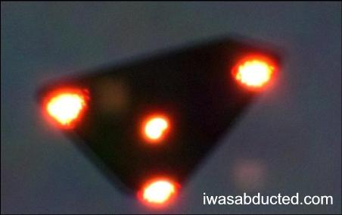
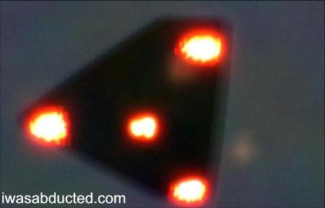
P. Ferryn in the INF #111 article wrote:
"Two photographs resembling strongly to the Petit-Rechain picture have appeared on an U.S. web site without any reference, analysis or explanation. The real date and time when they were taken is alternatively announced as November 29, 1989 or June 19, 1990. When I inquired to him, P. Ferryn present COBEPS President answered me on August 8, 2012:
"We know nothing about this case. Our association as well as former SOBEPS has never been informed of it. This copycat facsimile of the Petit Rechain photograph has been exhibited on the net [in the USA] for ages. The many requests for information I made to the site webmaster and various other U.S. sites on which it appeared have remained unanswered to date. No one has ever been able to give me the coordinates of this "Henrardi", or even to reply me. Needless to say he is totally unknown in the Belgian archives. This image reappears periodically here and there without any aditional info. That's all I can say about it".
More recently, the first photo was reproduced again in a the picture section of a book entitled "Le Feu des Magiciens" (Jerôme Huck, http://laboratoire.vulcain.pagerperson-orange.fr).
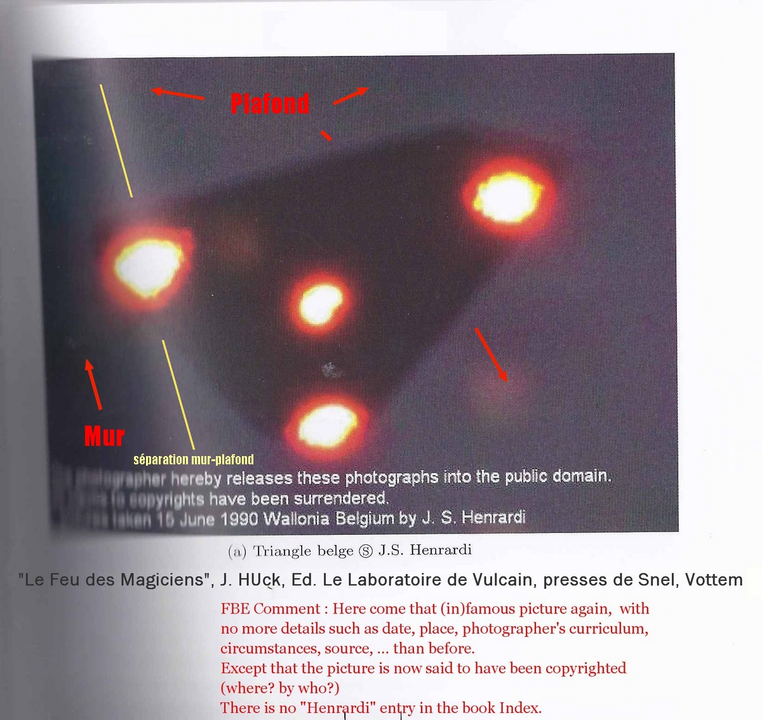

Next﻿

X. Photographic quality analysis
See following table
Table VI: Summing up of 78 cases versus last column Pan- Geipan estimate
Nr | Nr | 1 | 2 | 3 | 4 | 5 | 6 | 7 | 8 | 9 | 10 | Tot. | Pan-
1 | 8 |  |  |  |  |  |  |  |  | ● |  | 1 | D
2 | 20 |  |  |  |  |  |  |  |  | ● |  | 1 | D
3 | 26 | ● |  |  |  |  |  |  |  |  |  | 1 | B
4 | 211 |  |  |  |  | ● |  |  |  |  |  | 1 | C
5 | 10 |  | ● |  |  |  |  |  | ● |  |  | 2 | A
6 | 19 |  |  |  |  | ● |  |  |  |  |  | 1 | D
7 | 27 |  |  |  |  |  |  |  |  | ● |  | 1 | C
8 | 51 |  |  | ● |  |  |  |  | ● |  |  | 2 | C
9 | 52 |  |  |  |  |  |  |  |  | ● |  | 1 | D
10 | 57 |  | ● |  |  |  |  |  |  |  |  | 1 | A
11 | 87 |  | ● |  |  | ● |  |  |  |  |  | 2 | A
12 | 101 |  |  |  |  | ● |  |  |  |  |  | 1 | D
13 | 113 |  |  |  |  | ● |  |  | ● |  |  | 2 | D
14 | 115 |  |  |  |  |  | ● | ● |  |  |  | 2 | -
15 | 118 |  |  |  |  | ● |  |  | ● |  |  | 2 | C
16 | 125 |  |  |  |  | ● |  |  |  |  |  | 1 | D
17 | 130 |  |  | ● |  | ● |  |  |  |  |  | 2 | C
18 | 145 |  |  |  |  | ● |  |  |  |  |  | 1 | D
19 | 151 |  | ● |  |  |  |  |  |  |  |  | 1 | B
20 | 188 |  |  |  |  |  | ● |  | ● |  |  | 2 | C
21 | 198 |  |  |  |  |  | ● | ● |  | ● |  | 3 | -
22 | 200 |  |  |  |  |  | ● | ● |  | ● |  | 3 | -
23 | 203 |  |  |  |  | ● |  |  |  |  |  | 1 | D
24 | 222 |  |  |  | ● |  |  |  |  |  |  | 1 | A
25 | 11 |  | ● |  |  |  |  |  |  |  |  | 1 | A
26 | 23 |  | ● |  |  |  |  |  |  |  |  | 1 | B
27 | 25 |  | ● |  |  |  |  |  |  |  |  | 1 | C
28 | 40 |  |  |  |  |  |  |  | ● | ● |  | 2 | D
29 | 45 |  |  |  |  |  |  |  | ● | ● |  | 2 | D
30 | 56 |  |  |  |  | ● | ● | ● |  | ● |  | 4 | A
31 | 75 |  |  |  |  |  |  |  | ● | ● |  | 2 | C
32 | 78 |  |  |  |  |  | ● |  |  | ● |  | 2 | B
33 | 80 |  |  |  |  |  |  |  | ● | ● |  | 2 | C
34 | 83 |  |  |  |  | ● | ● | ● |  |  |  | 3 | -
35 | 85 |  |  |  |  | ● |  |  |  |  |  | 1 | C
36 | 100 |  |  |  | ● | ● |  |  |  |  |  | 2 | B
37 | 132 |  |  |  |  |  |  |  | ● | ● |  | 2 | D
38 | 139 |  |  |  |  | ● |  |  |  | ● |  | 2 | C
39 | 164 |  |  | ● |  |  | ● |  |  |  |  | 2 | C
40 | 168 |  |  | ● |  |  |  |  |  |  |  | 1 | C
41 | 172 |  |  |  |  |  |  |  |  |  | ● | 1 | A
42 | 175 |  |  |  |  | ● |  |  |  |  |  | 1 | C
43 | 176 |  |  |  |  |  |  |  |  | ● |  | 1 | C
44 | 189 |  |  | ● |  | ● |  |  |  |  |  | 2 | B
45 | 199 |  |  | ● |  |  | ● | ● | ● | ● |  | 5 | B
46 | 211 |  |  |  |  |  |  | ● |  | ● |  | 2 | -
47 | 215 |  | ● |  |  | ● |  |  |  |  |  | 2 | B
48 | 221 |  |  |  |  | ● |  | ● |  |  |  | 2 | A
49 | 243 |  |  |  |  | ● |  |  |  | ● |  | 2 | D
50 | 246 |  |  |  |  |  |  |  |  | ● |  | 1 | D
51 | 252 |  |  |  |  |  | ● | ● | ● | ● |  | 4 | -
52 | 299 |  |  |  | ● | ● |  |  |  | ● |  | 3 | B
53 | 24 |  |  |  |  |  |  |  |  | ● |  | 1 | D
54 | 26 |  |  |  |  |  |  |  |  |  |  | 0 | D
55 | 31 |  |  |  |  | ● |  |  |  |  |  | 1 | D
56 | 67 |  |  | ● |  |  |  |  |  |  |  | 1 | B
57 | 75 |  |  |  |  |  |  |  |  | ● |  | 1 | C
58 | 111 |  |  |  | ● |  |  | ● |  |  |  | 2 | C
59 | 23 |  |  |  |  |  |  |  |  | ● |  | 1 | D
60 | 41 |  |  |  | ● |  | ● |  | ● |  |  | 3 | A
61 | 51 |  |  |  |  | ● |  |  | ● | ● |  | 3 | D
62 | 56 |  |  |  |  |  | ● | ● |  | ● |  | 3 | -
63 | 128 |  |  |  |  | ● | ● |  |  | ● |  | 3 | D
64 | 65 |  |  |  |  | ● |  |  |  |  |  | 1 | A
65 | 70 |  |  |  |  | ● |  |  |  | ● |  | 2 | D
66 | 4 |  |  |  |  |  |  |  |  | ● |  | 1 | C
67 | 20 |  |  |  |  | ● | ● |  |  | ● |  | 3 | C
68 | 28 |  |  | ● |  |  |  |  |  | ● |  | 2 | C
69 | 31 |  |  |  |  |  |  |  | ● | ● |  | 2 | C
70 | 41 |  |  |  |  | ● |  | ● |  |  |  | 2 | D
71 | 43 |  |  |  |  | ● |  |  |  | ● |  | 2 | B
72 | 44 |  |  |  |  |  |  |  |  | ● |  | 1 | C
73 | 47 |  |  |  |  | ● |  | ● |  |  |  | 2 | D
74 | 48 |  |  | ● |  |  |  |  |  |  |  | 1 | D
75 | 55 |  |  |  |  | ● |  |  |  |  |  | 1 | D
76 | 71 |  |  | ● |  |  |  |  | ● | ● |  | 3 | B
77 | 27 |  |  |  |  | ● |  |  |  | ● |  | 2 | C
78 | 54 |  |  |  |  | ● |  |  |  |  |  | 1 | D
Total |  | 1 | 8 | 10 | 5 | 33 | 14 | 13 | 16 | 36 | 1 | 137
% on 78 |  | 1,3 | 10,3 | 12,8 | 6,4 | 42,3 | 17,9 | 16,6 | 20,5 | 46,1 | 1,3
For 7 (#14,21,22,34,46,51,62) out of the 78 notifications, no evaluation can be given, as they have not been investigated at all.Among the 71 remaining notifications, there is only one (#54 in the above
table) with 0 flaw is fit to replace the ominous PR (#54) slide. It is the Moignelée-Sambreville (Namur), whose date is uncertain, but for which a bona fide IR exists.
The Moignelée-Sambreville pictures are reproduced in the picture section of VOB1 (ill. 7-16bis. a-d).While being still considered a Pan-D, that notification could in my opinion be possibly downgraded to a meteorological balloon launching. There is no way to test that hypothesis as the investigators (Grede-Moinil) didn't check that issue when it was feasible; additionally the IR gives no indication on the speed and direction of the wind.
34(#1,2,3,4,6,7,9,10,12,16,18,19,23,24,25,26,27,35,40,41,42,43,50,53,55,56,57,59,64,66,72,74,75,78)present only 1 flaw and as such could be considered as would be candidates for further scientific evaluation.Out of them, 15 can still be considered as probable Pan-D, the combination of the two criteria (1 flaw and Pan-D) making them the most valuable:
1,2,6,9,12,16,18,23,50,53,55,59,74,75,78

A closer look on those 15 Pan-D cases that present only one flaw leads to the following observations:

Flaw | kind | Nbr of cases
#5 | unexploitable  document | 8(6,12,16,18,23,55,75,78)
#9 | unknown, not  archived or lost document | 7(1,2,9,50,53,59,74)
Even if those reports don't make me very optimistic, only those two categories summing up 15 notifications could be of possible scientific interest in order to comfort an outlandish origin of the 1989-1993 Belgian unidentified objects.Only a prolonged, painstaking and minute re-examination of those cases and the eventual localisation of the 7 claimed photographic evidence documents flawed #9 could save a reasonable "alien" hypothesis picture evidence for the 1989-1993 VOB.This only represents a mere 0,5% out of a total amount of (see Table 1) 1,282 notifications.
3. Probable or certain aircraft: 7 cases, 7.4%
7. No IR: idem
.4. Electrical disturbances, rocket fireworks, lighting, reflections: 4 cases,4.2%
1. Satellite likely or certain: 1, 1%
10. Deception (Petit Rechain): 1, 1%
In once case out of 4, the witness obviously did not knew how to make a profitable use of the habitually sophisticated equipment he held in his hands. In other circumstances, the material proved inadequate. Using a flash to photography of an object more than 20 m distant is simply ridiculous, but most of witnesses simply ignore it a this bia comes again and again like a litany.We are finally left with one single exploitable case :
Next﻿

90-1 # 25 Moignelée-Sambreville - Namur - between 13 and 17/8/1990 - ~ 22.30 - E
3: M. David T., 15 ½ years, his grandfather, a neighbor, M. Marcel T.Pleasant evening, clear skies, no wind.While chatting with a neighbor on the terrace of his grandparents' home, David noticed towards the E a distant yellowish-white form. It was not standing still, but animated by a whirling counterclock motion. He immediately called his grandfather who went in search for a camera. When he came back with it, the phenomenon had faded away by extinction, before it reappeared further to the left. It emitted four flashes, each one separated by 4 seconds from the previous one. After that, the phenomenon faded away a second time, then a third time before moving on again to the left. It finally completely disappeared.
Observation duration: ~ 4 minutes
Inv. G. Grède and D. Moinil.
VOB1, 412-413
CR=3, SR=3; ND
Pan-D
476
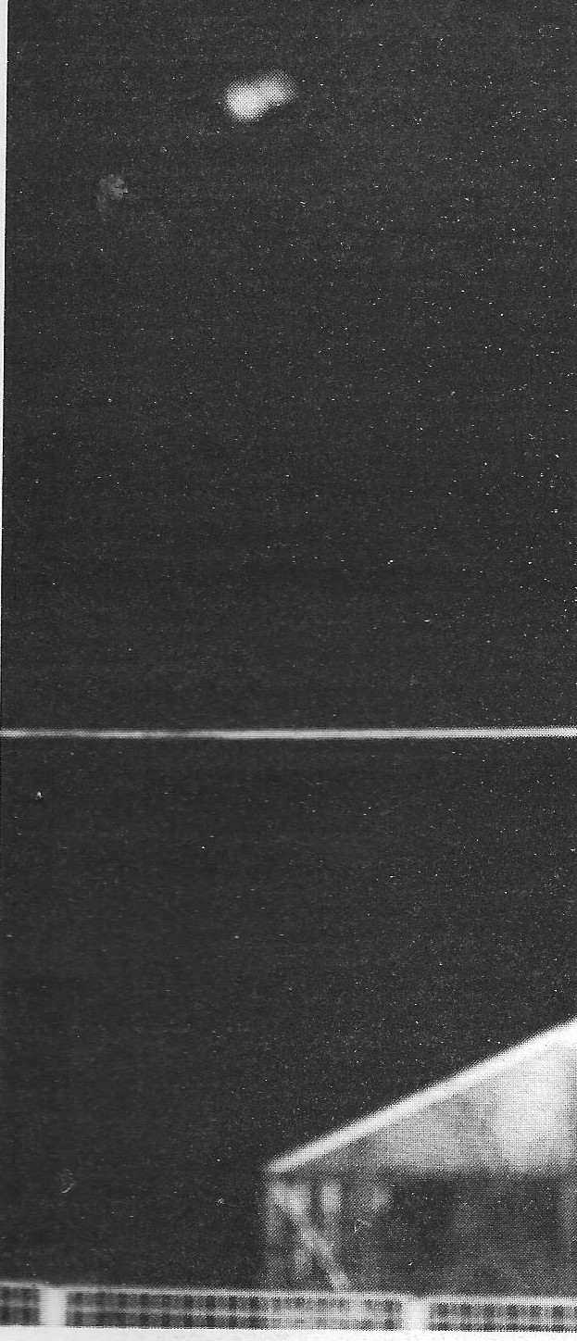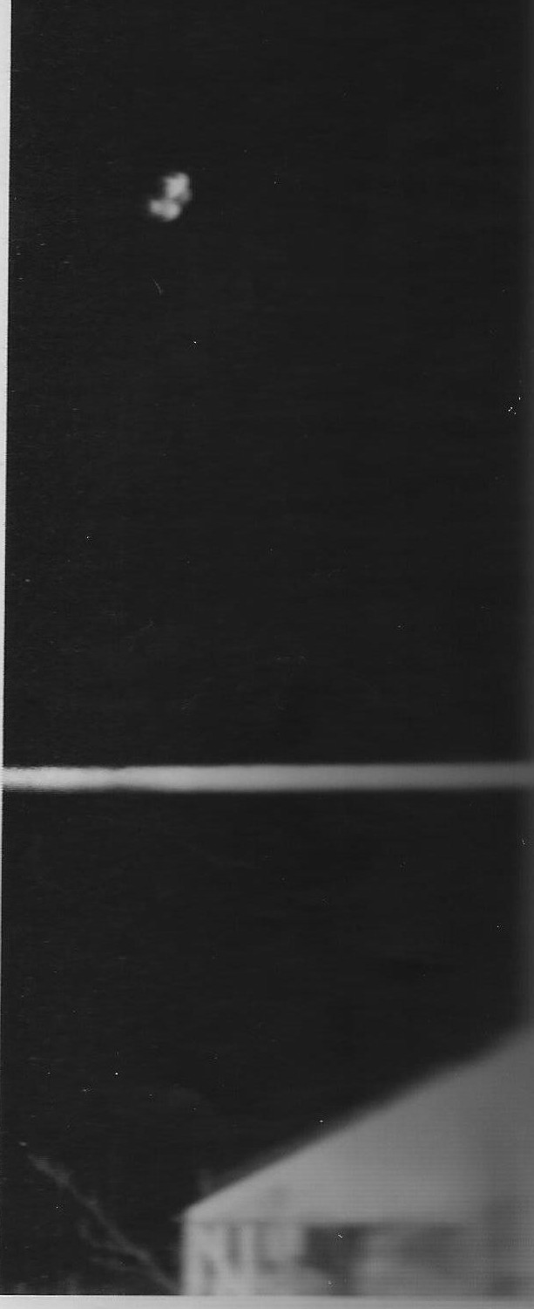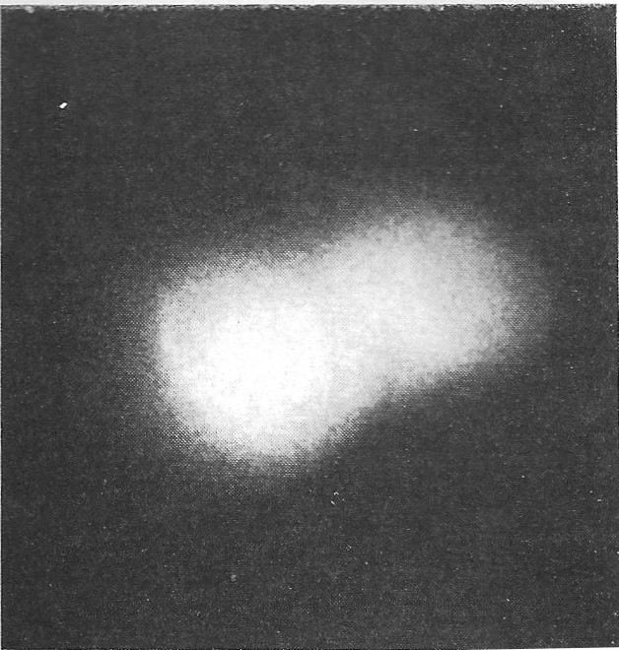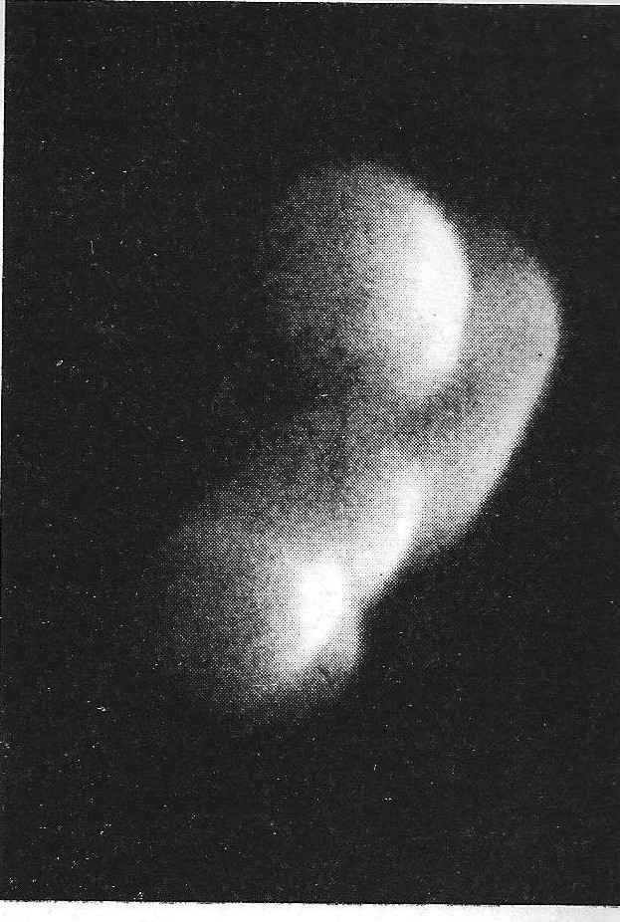
VIII. My comments on the Moignelée-Sambreville case

Investigators believe the three witnesses to be sincere and credible. Unlike the Petit Rechain picture, there is a foreground to be seen on the phictures. The clear horizontal streak seen on shots #1 and 2 is a rope used to play
badminton. Its height compared to the building in the background on shot #1 shows that the photographer was very close of it. On shot #2, the photographer has slighlty moved forward. Also note in the lower left corner the presence of
branches, weed or shrub.Mr. Moinil is a professional photographer. Following VOB1,412 "having carefully examinedd the original negatives and engaged various recovery tests on site [he believes] that the pictures cannot be those of a short distance small object [model]" for the following reasons:
1 / Foreground (the greenhouse less than 10 m away from the witness, the horizontal wire fence) is blurred, which means that the camera was set on infinity and therefore the object was necessarily at greater distance than 20 m.
2 / The flash was set to 1/30th of a second, causing a replication of certain details.
3 / The sideways illumination of the spheres (see shot #4) cannot have been caused by the flash, as would have been the case with a nearby object.
Even if, seen the circumstances, the falsification seems to me excluded, I (FBE) find regrettable that the date is not known more precisely, the absence of azimuth ("in the direction of E") and the absence of any information on the possible presence and what the illuminated portion of the moon was.The, possibly due to a feeble wind, rotation hypothesis seems compatible with the hovering of a weather balloon. I do not know if investigators have questioned that possibility.As it is not explicitly stated that the phenomenon was silent, the assumption of a possible plane seems equally feasible. Apart from these reductive three possibilities, I do not see any others.Despite these very light restrictions, the Moignelée-Sambreville pictures become now what I consider as the only available candidates capable of replacing the Petit Rechain.VOB1 ends with: "(...) we are foreseeing additional research (…) to substantiate these preliminary findings" (413).Has this analysis been carried on since then? Permit me to doubt it.
Next﻿

XI. How the 89-93 Belgian Ufo wave began
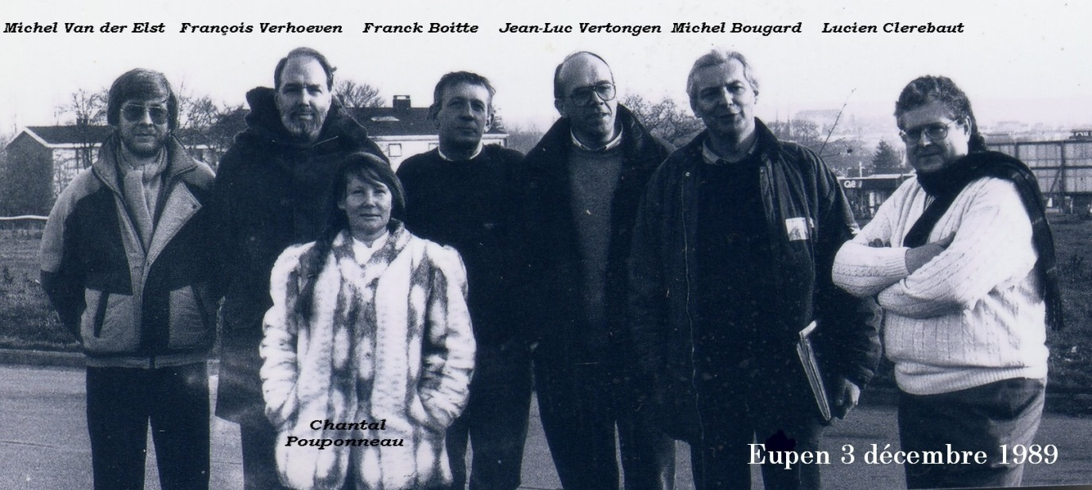
The wave reached its peak on November 29th 1989. But, as I explained and as Table III demonstrates, it had started unnoticed a good month before. When on Tuesday 30, I heard on the TV News release about the von Montigny-Nicholl gendarmes repeated observations on the previous day, my first reaction was that it was a hidden camera gag for a new de Funès style "Les Gendarmes de Saint Tropez" remake.
SOBEPS Chief Investigator J.L.Vertongen phoned me the following day, telling me SOBEPS was drowning under a pile of notifications awaiting to be investigated and asking me if I 'd be willing to participate? When yes, a gathering was to be held on the GB Eupen Supermaket parking lot around twelve a.m. on December 3rd Sunday. That's when the above picture was taken and I'm very proud of it.
The seven people there were what was left of the SOBEPS Investigation Team at the time. Let's rather say six, as the lady's - who later on was to become my second wife - experience in investigating ufos was zero.
It was the Grenz Echo reporter who took the picture who asked her to stand on it. Seen the criticizing and humbug that would follow those early investigations, it is enlightening to note who was there, and who was not. Except J.L. Vertongen and me, most of the other people there had no or little UFO investigation experience. For example, MM. Bougard and Clerebaut were respectively SOBEPS President and General Secretary. Their main ocupation dealt with public relations and administrative tasks and didn't dealt with field investigations.
XII. Overall conclusion
﻿The almost noiseless hovering resulted in it had cut its engines to spare fuel, and it actually was moving at a much higher than estimated by the witnesses. In support of his refutation, M. Paquay produced a serie of pictures of landing Boeing 747 aircrafts he took at Zaventem National Airport and I must admit that their resemblance with Ramillies one is troublesome. Additionnally, it was only recently revealed that if one prolongs in a straight line the azimuth where the UFO appeared to the witnesses's position, it directly leads to Bierset Airport which was not consulted on the possible presence of a landing airplane at the time of the facts.
In an email dated October 30, 2012 he adressed me, Mr. Ferryn wrote:
"Neither Bierset nor Beauvechain airports were at the time able to bear on a Boeing 747 landing. Please notice I never boasted the picture I took illustrated an "extraterrestral platform". I actully still wonder what kind of earthly or unearthly aircraft I protographed." More generally speaking, he wrote me on October 1, 2011: "The Petit Rechain photograph was the only one of the whole Belgian wave - and even of the whole Belgian ufology - which reveals the famous"mass carrier" lights so frequently described in both SOBEPS books." This lack of documents is very frustrating to anyone willing to tackle the problem from a really scientific point of view, and match the eminently disillusioned remark of the then director of GEPAN, M. C. Poher: "Of all the UFO pictures I examinated which have not proven to be deliberate fakes, I've never seen a mere single one where an unidentified object appears with a sharp and close definition." He made this declaration during a casual break conversation with participants of the Second International Workshop on UFOs organized, like the previous year, with the participation of many European ufologists such as the late P. Guerin by journalist J.C. Bourret and the Grenoble municipality support, on June 16-17, 1976.
What finally is left of the 89-93 Belgian Ufo wave? The residue is a rather impressive body of anecdotal, often strange and thrilling incidents that in my opinion only "prove" that definitely "something strange" happened in the eastern part of Belgium along the German border during this period and especially between October and December 1989. After that, the events became over-mediatized, leading to an almost hysterical climate of "UFO hunting" in a guillible and easy to confuse public.
As Dolan's second Ufo book clearly documents, it's striking to realize that at the same time, the rotting Soviet Empire had its share of equally unexplained sightings, as if the two continents which had been for more than foury years engaged in a cold war that on a few occasions theatened to turn into a very heated confrontation, had during that whole period been under the close scrunity of a Fleming's kind of SPECTRE behind the scenes organization.
Acknowledgments
After a first french version of this article appeared in the autumn 2011 # 68 issue of UfoMania, I was fortunate enough this publication aroused the interest of Vicente Juan Ballester Olmos, Fotocat Webmaster (see : http://fotocat.blogspot.com) who persistingly asked me minute precisions on photographic cases. During a six months period of sometimes painstaking exchanges, his welcomed insisting interventions helped as well to correct some discrepancies as well to improve the text both in number of cases and precision.Thank you Vicente for all your work and dedication.
I want also cheerfully want to thank Ph.D. Jean-Pierre Rospars who spent many hours of his scarce spare time to translate my sometimes wobbly and approximate american-english into a more readable and consistent form. It was an honour and a pleasure Jean-Pierre to be helped by someone like you.Thank you to you too, Chris, to have accepted this publication for the Canadian Ufo Survey.Only by a wide international info exchange can we hope to make some progress in the comprehension of this so elusive and exciting research.

Further reading
F. Boitte, "Analyse des Rapports d'Enquête de la période 89-91 (1ère partie)" Inforespace 84, août 1992.
F. Boitte, "Analyse des Rapports d'Enquête de la période 89-91 (2ème partie)" Inforespace 85, décembre 1992.
R. Perry Collins, "The wave of "wing" reports: more on the "boomerang ": "as large as two football fields": March of 1983 to Nov. 1985 eastern United States triangle shaped reports.
Flying Saucer Review vol.31-3, 1986.

R. Dolan "UFOs & The National Security State: The Cover-up exposed, 1973-1991", Keyhole, 2009.
Lorne Goldfader, "Ufo Report for Canada, 1990-1992": reports on Canadian triangle and wing shaped
objects observations.
Flying Saucer Review vol.38-4, 1993.
Chris Rutkowski, "The Canadian wave: an analysis", International UFO Reporter, vol.15-4, Juil-Aug. 1990: analytical
reporting on 1989 137 canadian cases.
Chris Rutkowski, "The 1991 Canadian Ufo Survey", Uforic: analytical reporting on 194 1990 & 165 1991
canadian cases.
J. Vallée & M. Costello "Ufo Chronicles of the soviet Union: A Cosmic Samizdat", Ballantine Books, March 1992: Vallée's on the spot investigation on the (in)famous October 1986 Vorojnev landings.

Franck Boitte
october 2012
﻿

